The Gaussian Distribution Meaning, Derivations, Simulations

Marco Pasciullo

2094810

1. **INTRODUCTION**

The Gaussian Distribution, also known as the normal distribution, is one of the fundamental concepts in statistics and probability theory. In this research paper, we will explore the meaning of the Gaussian distribution, some important derivations, and how it can be simulated.

1. **MEANING OF THE GAUSSIAN DISTRIBUTION**

The Gaussian Distribution is a continuous probability distribution that is symmetric around its mean. It is fully characterized by its two parameters: mean  and standard deviation . . It’ s bell-shaped curve indicates that central values are more probable than extreme values.

1. **DERIVATIONS OF THE GAUSSIAN DISTRIBUTION**

**3.1) Probability Density Function (PDF)**

The Probability Density Function (PDF) of the Gaussian Distribution is given by:

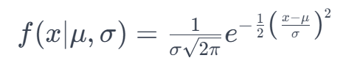

x = is the random variable

**3.2) Integration of the PDF**

The integration of the PDF over the entire domain yields the area under the curve, which is always equal to 1. This represents the fundamental property of any probability distribution.

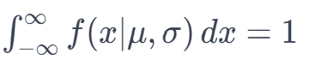

1. **Simulations of the Gaussian Distribution**

We can simulate the Gaussian distribution using the Python programming language and the NumPy library. For example, the following code generates a random sample of 1000 points from a Gaussian distribution with a mean of 0 and a standard deviation of 1:

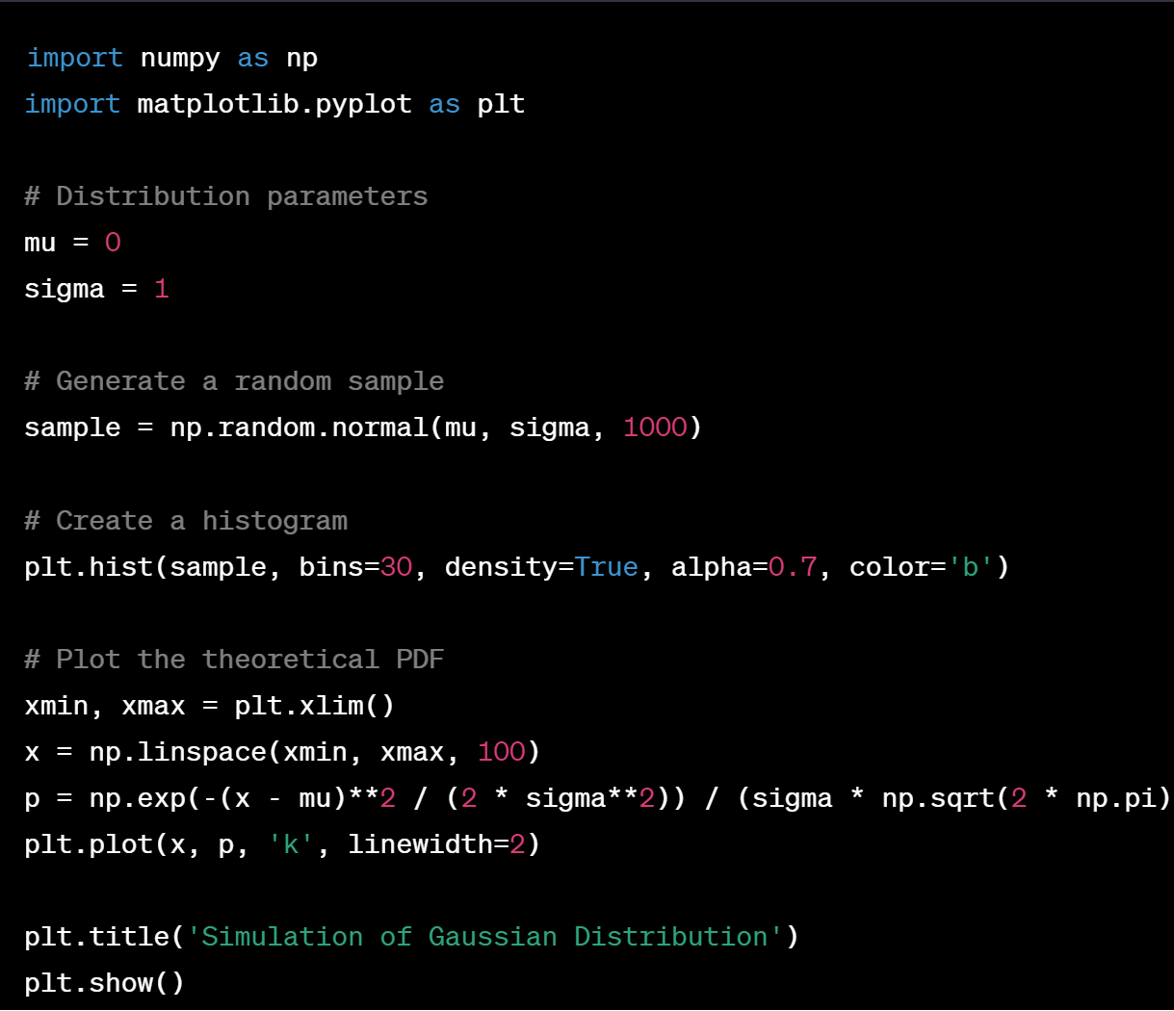

1. **Conclusions**

The Gaussian Distribution is a fundamental concept with applications in various fields, from statistics to physics. Its characteristic bell-shaped curve and mathematical properties make it a powerful tool for modeling and understanding various phenomena. Through derivations and simulations, we have explored the basics of the Gaussian distribution, but it's worth noting that its importance extends to many other areas of mathematics and applied sciences.